Celebration of Digital India Week
Dt: 2nd July 2015
Organized by: Rashtriya Madhyamik Siksha Abhijan, Kamrup Metro
Venue: Conference Hall, Inspector of Schools, Kamrup Metro

One day awareness programme on Digital India Week was celebrated by RMSA, Kamrup Metro in the conference hall of the Inspector of Schools Kamrup office on 2nd July 2015 at 10.30 am.
The meeting was attended by following dignitaries:
- President: Sri Kamal Gogoi, (AES) Inspector of Schools cum DPC RMSA, Kamrup-Metro
- Resource Person: Sri Sujan Purakayastha, DIO, NIC Kamrup-Metro
Smt. Barnali Patgiri, Addl. DIO, NIC Kamrup-Metro
- Sri Babul Ch Kalita: Secretary, Academic Council, Kamrup-Metro

Around 140 Vocational IT/Retail Student and Teachers of Kamrup-Metro schools participated in the programme.

The programme started with an inaugural Bhajan by Sri Jayanta Sarma music teacher TC Govt. HS & MP School. The Guests were felicitated by District Consultant with a Phulam Gamucha. After that, the purpose of the programme was described by District Consultant, RMSA Kamrup-Metro.
The DIO, NIC Kamrup-Metro has made a power point presentation on the allotted topics of the programme: CYBER HYGIENE, E-WASTE MANAGEMENT AND DIGITAL LOCKER. He describes the various threats faced by cyber users from hackers. He also pointed out some steps that the computer users can take to improve their cyber security and better protect online. He describes in detail about the E-Waste which are considered dangerous and pose a threat to the human health and environment. To reduce the administrative expenses the use of DIGITAL LOCKER is of utmost importance now a day. GOI has launched Digital Locker service in February 2015 under Digital India Programme which gives free access to the users to store their valuable documents in digitized format.

The President in his speech, advised the students to study hard in order to be successful. He gave them a few tips for success in life. He also urged the teacher fraternity to come forward to the digital age and bridge the gap of learning of modern time. The Vocational teachers were advised to be proactive and assist other teachers of their respective schools to use cyber technology in modern day teaching.
A video on Spoken Tutorial Project sent by Ms Mousumi Medhi of IIT Bombay is shown during the programme. The president lauded Ms Medhi’s efforts in making this Project successful in Assam. The Spoken Tutorial Project is about teaching and learning a particular FOSS (Free and Open Source Software) like LibreOffice (an alternative of MS Office). IT Teachers of Rajdhar Bora HSS and Kamrup Academy HSS also spoke about the Spoken Tutorial Project and its effectiveness in their schools.

At the end of the meeting Sri Babul Ch Kalita offered vote of thanks to the attendees.

Some Pictures of the Programme:
- DIO, Kamrup Metro is showing power point presentation.
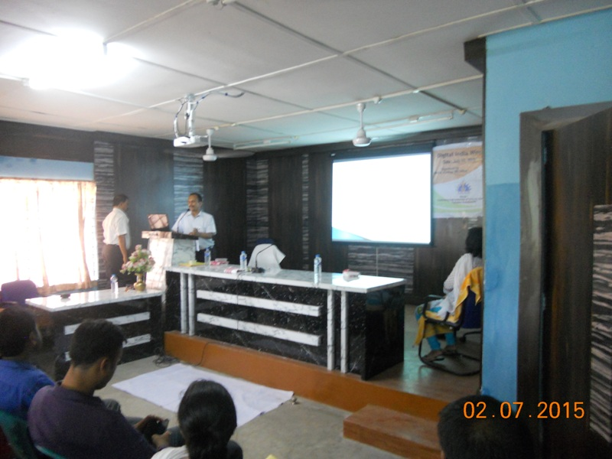

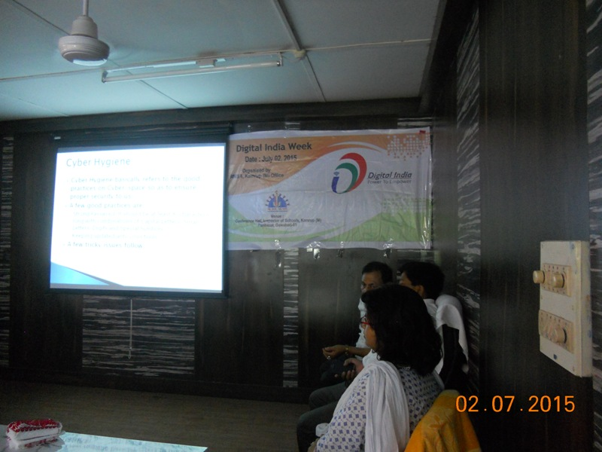

- Inspector of Schools cum DPC RMSA is delivering his speech

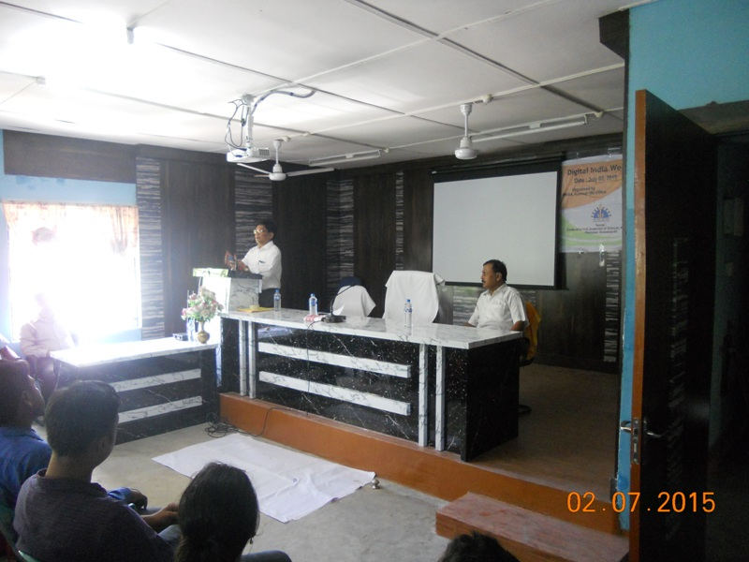

- Attendees
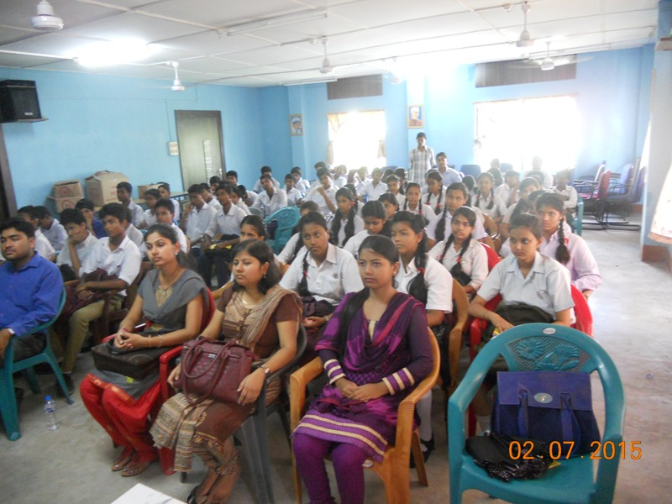

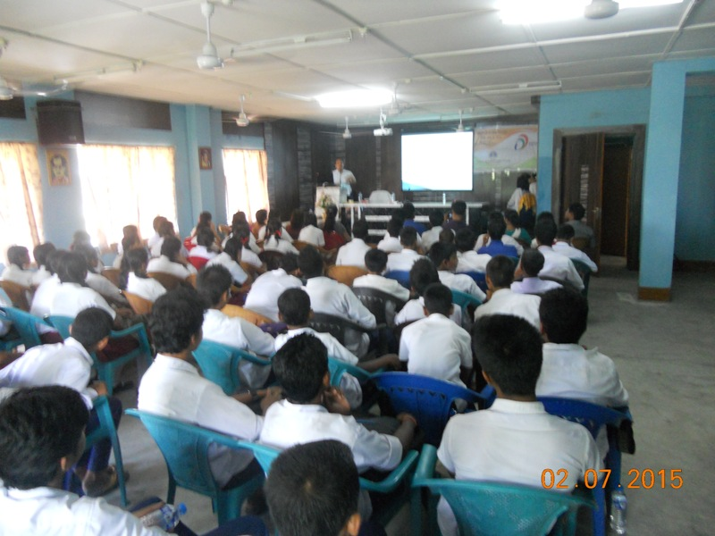

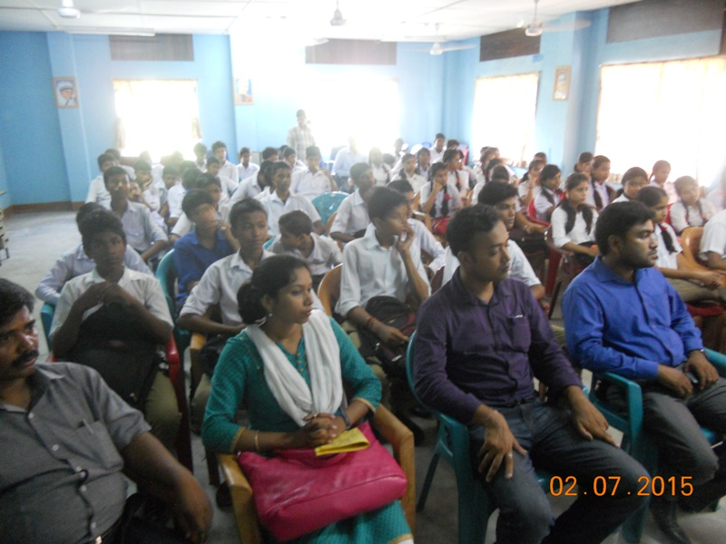

- Vote of thanks offered by Sri Babul Ch Kalita

